

tutorials ninja

Test Plan

URL: ([[Your Store](https://tutorialsninja.com/demo/))](https://masiowatch.netlify.app/)





PROJECT NAME: TUTORIALS NINJA

PREPARED BY: PRINCE KUMAR SARSWAT

masai

Date: 17-01-2025

Date: 02-10-2024

Table of Contents

Introduction…………………………………………………………………………………………………………… 3

objective………………………………………………………………………………………………………………… 3

Scope……………………………………………………………………..……………………………………………... 3

Testable features…………………………………………………………….……….…………………………….. 3

Testing approach……………………………………………………………………………………………………. 4

Roles/Responsibilities ……………………………………………………………………………………………. 4

Test Schedule ………………………………………………………………………………………………………… 4

Test Deliverables …………………………………………………………………………………………………… 5

Entry & Exit Criteria ………………………………………………………………………………………………. 5

Tools ……………………………………………………………………………………………………………………… 5

Risks and Mitigation plans……………………………………………………………………………………… 5

Approvals ……………………………………………………………………………………..………………………. 5

Mind Map Overview………………………………………………………………………………………………. 6

1. Introduction

This test plan outlines the objectives, scope, and testing approach for the TUTORIALS NINJA Web Application. The goal of this testing process is to ensure the product meets the business requirements, is bug-free, and operates as expected under different conditions.

AUT: [Your Store](https://tutorialsninja.com/demo/)

**2. Objective**

- The Tutorials Ninja platform is an e-commerce website that offers a broad range of products, such as electronics, fashion, home goods, and more. The website supports browsing, cart management, and checkout processes. The goal is to perform both manual and automated testing to ensure the platform is fully functional and provides a seamless user experience.

- To ensure the functionalities of key features such as product search, add to cart, checkout, and account management.

- To confirm compatibility with different browsers.

**3. Scope**

- This test plan cover end to end testing which contain all level of testing of the TUTORIALS NINJA web application across different browsers and OS**.**

**4. Testable features:**

* **User Registration and Login**
* **Product Browsing and Display**
* **Search Functionality**
* **Cart Management**
* **Checkout Process**
* **Order History**
* **Account Management (Update Details)**
* **Promo Codes and Discounts**
* **Multi-currency Support**
* **Mobile and Cross-browser Compatibility**
* **Security Features**
* **Error Handling**

**5. Testing Approach:**

**-> Testing Types**

- Functional Testing

- Compatibility Testing

**-> Testing Methodologies**

- Black- box Testing

- White-box Testing

- Regression Testing

- User Acceptance Testing(UAT)

**-> Testing Environment**

- UAT

- Pre-Prod

**-> Operation System**

- Windows 11 and above

- Browsers: Chrome, Firefox, Edge

- Testing Tools: Manual Testing

**6. Roles/Responsibilities**

|  |  |  |
| --- | --- | --- |
| **Name** | **Role** | **Responsibilities** |
| Prince Kumar Sarswat | Test Engineer | End to End Manual Testing |
| Abhishek Mourya | Test Engineer | End to End Manual Testing |

**7. Test Schedule**

- Following is the Test Schedule planned for the project

|  |  |
| --- | --- |
| **Task** | **Time Duration** |
| Test Plan Creation | 18-01-2025 |
| Test Scenario Creation | 18-01-2025 |
| Test Case Creation | 18-01-2025 |
| Test Case Execution | 18-01-2025 |
| Bug Report | 18-01-2025 |
| Summary Report | 18-01-2025 |

**8. Test Deliverables**

- The following are to be delivered to the client:

|  |  |  |  |
| --- | --- | --- | --- |
| **Deliverables** | **Description** | **Responsible Owner** | **Target Completion Date** |
| Test Plan | Outline the testing approach, strategies, and scope for the web application | MASAI | 18-01-2025 |
| Test Case | Test cases created for End-to-End manual Testing | MASAI | 18-01-2025 |
| Bug Report | Detailed description of the defects identified in different versions of application. | MASAI | 18-01-2025 |
| Summary | Summary of all bugs and reports | MASAI | 18-01-2025 |

**9. Risks and Contingencies**

Risk 1:

Mitigation Plan:

**10. Approval and Sign-Off**

| Role | Name | Date |
| --- | --- | --- |
| Test Lead | Prince Kumar Sarswat | 18-01-2025 |
| Project Manager | Shiva Kumar M G | 18-01-2025 |

|  |  |  |
| --- | --- | --- |
|  |  |  |

MIND MAP FOR THE PROJECT: TUTORIALS NINJA

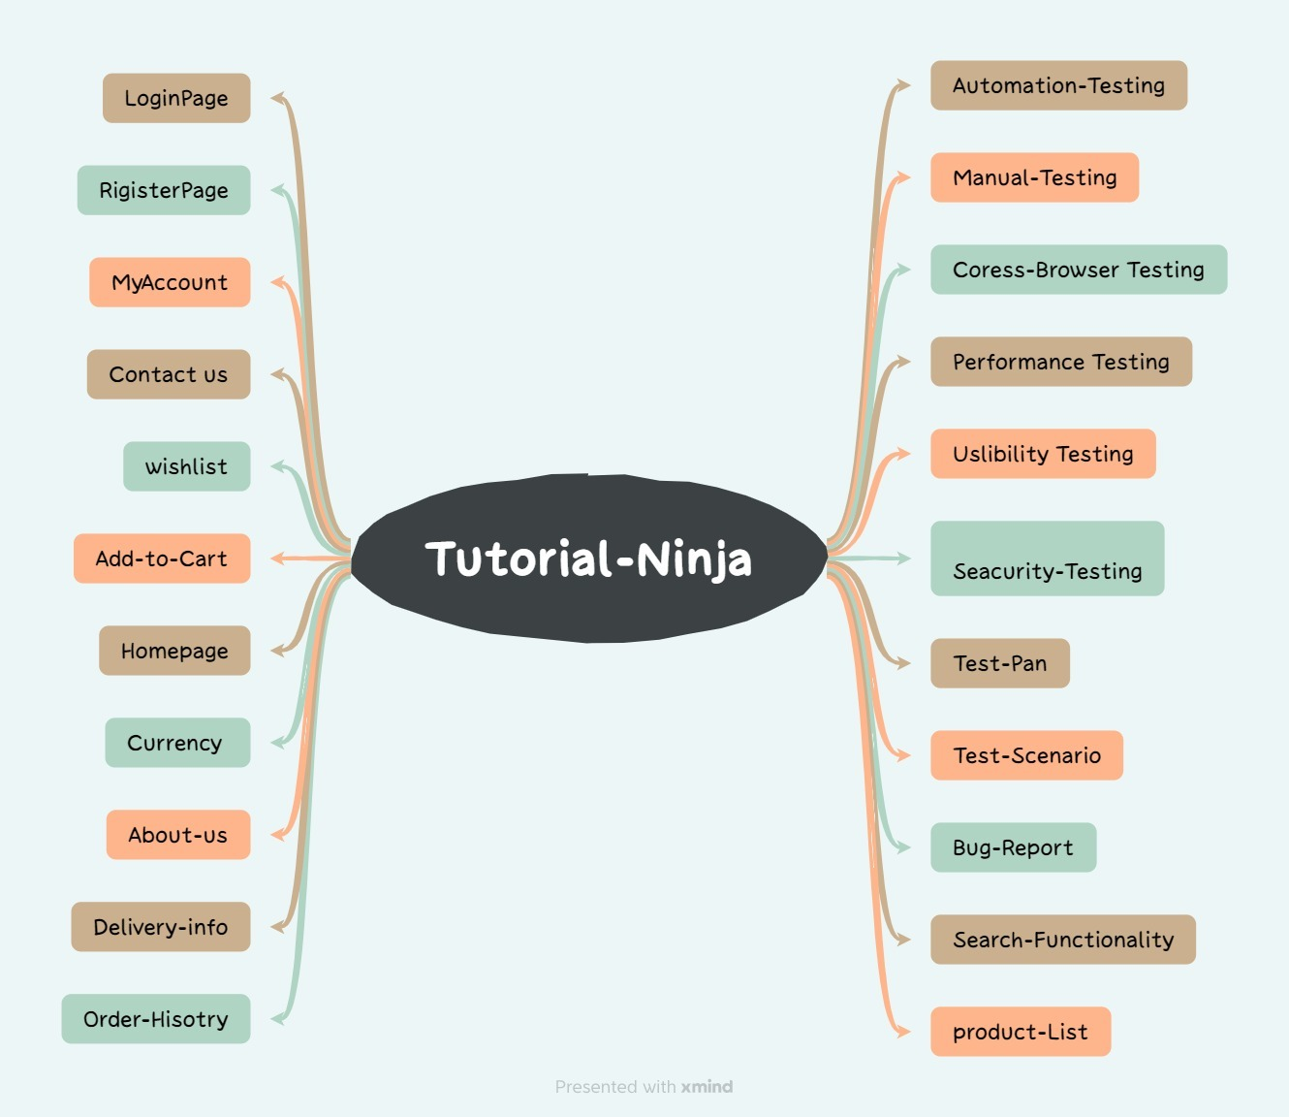

**Mind Map Overview**

The mind map illustrates the key modules and testing aspects of the Tutorials Ninja project. It is structured into two main categories:

Application Modules:

Login Page: User authentication and access functionality.

Register Page: User sign-up and account creation process.

My Account: User account management features.

Contact Us: Communication and support features.

Wishlist: Save items for future reference.

Add-to-Cart: Add products to